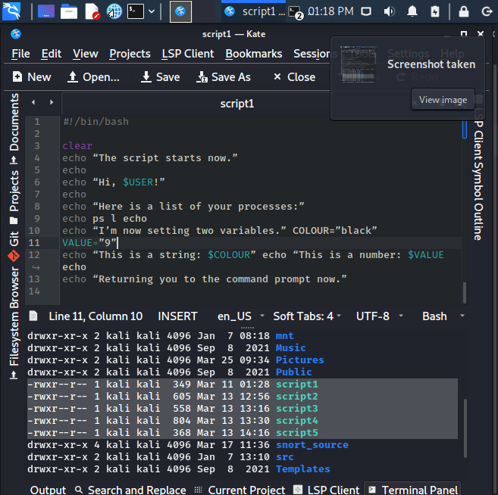

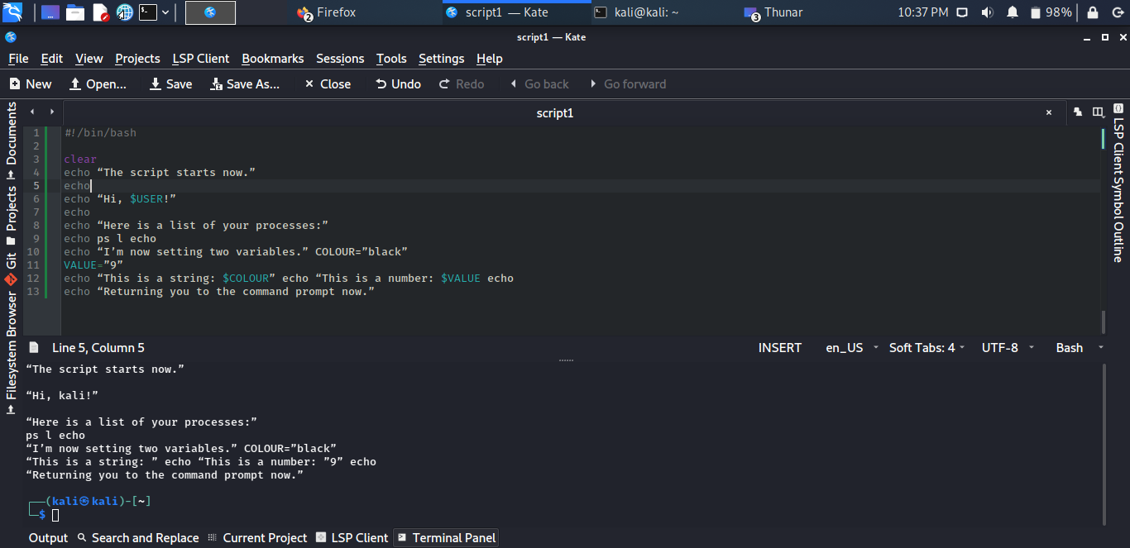

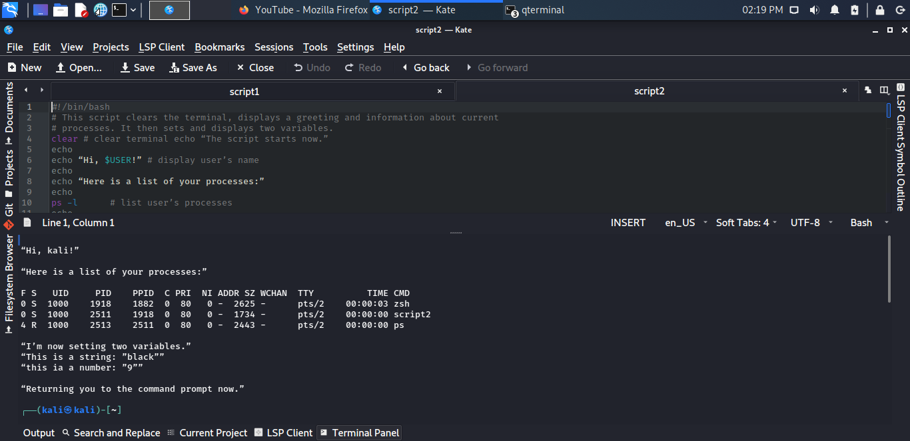

Script 3

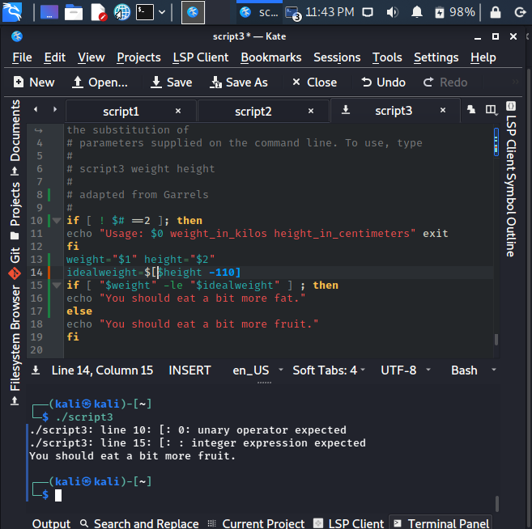

What is the significance of the variables, $#, $1, and $2?

$#: number of arguments on command line

$1 : accepts the first parameter

$2: Accepts the second parameter

**If you ran the command script3 95 193 What would the values of $#, $1 and $2 be? Make a note here:**

$1=95,

$2=193,

$#=3

Script 4

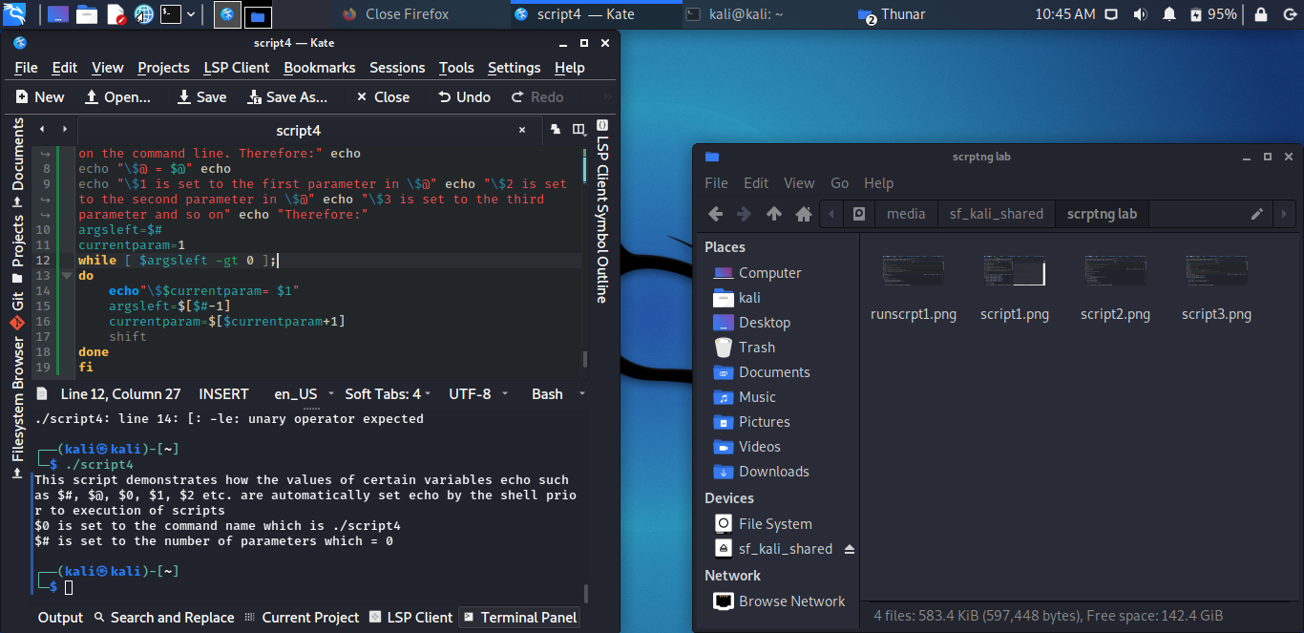

Script5

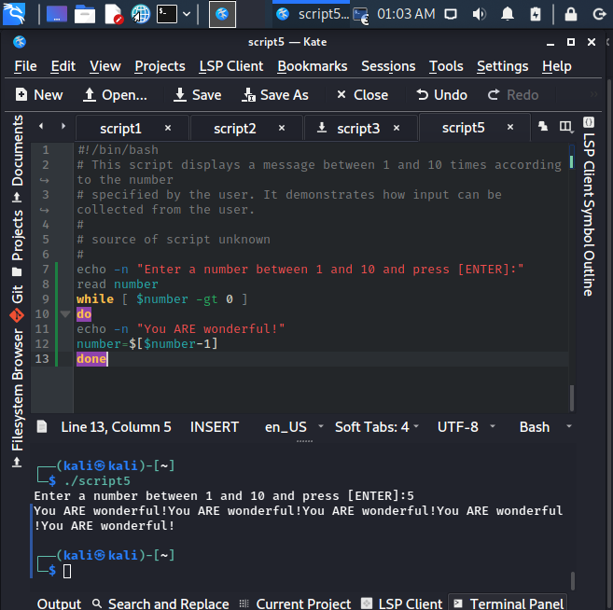

what happens if you enter a number outside that range or indeed no number at all or a nonnumeric

character? Try some of these scenarios. Make a note of what happens.

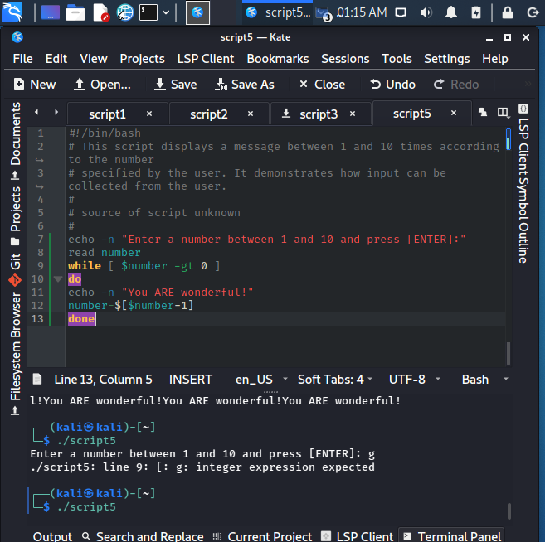

For nonnumeric character it returns the error “ integer expression expected”.

For a number outside the range of numbers, it returns “ you are wonderful” n times the input.